**Paper Template for the The ICME2023, International Conference on Manufacturing Engineering (Times New Roman 12pt, Bold)**

Identify the corresponding author by uppercase star (*) after the name.

|  |
| --- |
| **First Author1, Second Author2*, Third Author3 (Times New Roman 9 Bold)** |
| 1-First­ Author’s Position or Job Title, Affiliation and short Address (Times New Roman 9) |
| 2,3-Second & Third Authors’ Position or Job Title, Affiliation and short address  • Common Titles and addresses should be appeared only once, e.g., see the second and third authors’ address  • If all authors have a common title and address, no number is needed. |
| Job Titles included: BSc or MSc or PhD (student or graduated); Assistant Prof. or Associated Prof. or Professor. |

# Abstract

Consider two 9pt lines between the addresses and abstract

This template helps the authors to prepare their manuscript in the best manner and the shortest possible time. The manuscript should describe the main objectives of the research, the method of investigation, and the outcomes and achievements supported by obtained results. The paper should be written in two-column format using Times New Roman 9pt. According to this style, the paper must be prepared within 4 to 6 complete pages. It must be accompanied by a 150 to 200 word abstract written as a single paragraph and reference mentioning should be avoided in the abstract. Insert the abstract two-9pt lines after the last line of authors’ affiliations and addresses.

**Keywords:** *Minimum 3 and**Maximum 5 words separated by “-”, using Times New Roman 9pt Italic.*

# Introduction (Maximum 200 words)

This instruction provides the required guidelines to let authors write their English papers in accordance with the format prescribed by the conference. The fulfillment of the described instructions is mandatory for all contributors. Note that the appearance of this template conforms to the described directions.

The authors of English papers are strongly recommended to use Microsoft Word 2016 in Windows. Use Times New Roman 9pt and single space for the entire body, except the beginning of section titles, the line after figure caption, and so on. The paper should be formatted in two columns with the margins specified on this template (2.5cm from left, 2.0cm from right and 2.0cm from top and bottom). Each section title or subtitle should be appeared in Times New Roman 9pt boldface with one blank line space from the bottom of its preceding section. Avoid numbering sections and sub-sections. Please don’t change the sections’ titles.

The first line of each body paragraph except that is immediately appeared after the title of each section, should have an indentation equal to 7mm.

# Problem Explanation, Innovations & Aims of Paper

Each paper will be evaluated, if and only if, it respects the required format described here. Moreover, the paper should be submitted only via the conference website. Please include all the relevant materials (text and accompanying figures) into a Docx file and upload it to the conference website. The conference accepts papers with a size less than 3.0 M. Bytes.

# Research Method and Assumptions

It is a convention to specify the method of study as well as the key assumptions.

All equations (in one or more lines) must be written in the center of line using Times New Roman font and appropriate size. Number all equations sequentially form 1. Each equation number should be right justified written in parentheses, see Eq. (1). Relevant theories and equations should essentially be adequate and not to be elaborated. An approximate relation between *r* and *V* vectors is given by:

 (1)

where *ψw*and *ψb* are definitions 1 and 2, respectively, for a particle with velocity  at position  and time *t*.

It is not necessary to bring a list of nomenclatures at the beginning of the paper; each variable or symbol must be defined properly right after its first implementation.

# Results and Discussion

In the Results section, present the collected data and the analysis performed on those data relevant to the discourse that is to follow. Report the data thoroughly to justify your conclusions. Mention most relevant results, including those that run counter to expectation.

Each table must have a number and a caption written on its top using Times New Roman 8pt in boldface. The content of tables is written using Times New Roman 8pt. Tables may place within the texts or just before the figures. All quantities in tables should be accompanied with their units, see Table 1. Place each table with one line left from its preceding and following texts.

**Table 1: Computed parameters at two considered sections for U=20 m/s**

|  |  |  |
| --- | --- | --- |
|  | *Vp* (*m/s*) | *T* (*K*) |
| results in section 1 | 18 | 311 |
| results in section 2 | 24 | 294 |

All figures and drawings must be placed within the text in a proper location. Drawings must be clear and sharp. Letters, numbers, and legends in illustrations should be large enough to be legible. Each figure must have a number and a caption. Captions should be placed under the figures and should be written using Times New Roman 8pt in boldface. Cite all figures within the text, e.g., see Fig. 1 and its caption.

# Concluding Remarks

Each paper should be accompanied with a comprehensive conclusion section, right after the body of the article and before the reference list.

QT1

**Fig. 1: The construction of finite volume from its neighboring elements.**

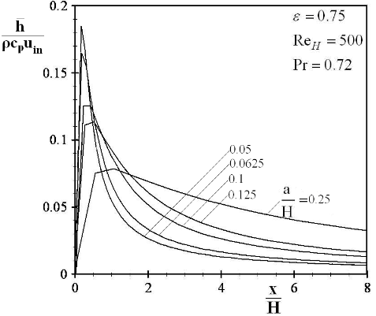

**Fig. 2: An example of a figure**

# References

References, as the final part of each paper, should be written by Times New Roman 9pt. They are ordered as they are cited. For each reference, adequate specifications should be mentioned according to a standard format such as the following examples. If you are indicating a document published in Persian language, please write it in English and adds the expression "In Persian" at the end of it. Please notice to the following sample references:

1. Author, A., Author, B., and Author, C., 1994. “Article Title”. *Journal Name*, 1(5), pp. 1–3.
2. Author, A., 1986. *Book Name*. Publisher Name, Address.
3. Incollection, A., 1991. “Article title”. In *Collection Title*, A. Editor, ed., 3rd ed., Vol. 2 of Series title. Publisher Name, Publisher address, Chapter 1, pp. 1–3.
4. Inproceedings, A., 1991. “Article title”. In Proceedings Title, A. Editor and B. Editor, eds., Vol. 1 of *Series name*, Organization Name, Publisher Name, pp. 1–3. Paper number 1234.
5. ASME, 2003. *ASME Manual* MS-4, *An ASME Paper*, latest ed. The American Society of Mechanical Engineers, New York.
6. PhD thesis, A., 2016. “Thesis Title”. PhD Thesis, University of Tarbiat Modares, Mechanical Faculty (In Persian)